Autumn 1 | Autumn2 | Spring 1 | Spring 2 | Summer 1 | Summer 2
Inspiring Books used for writing
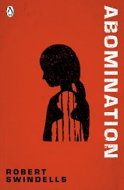  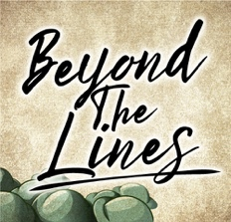 | 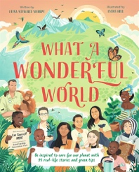  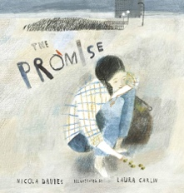 | 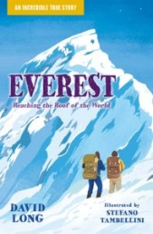  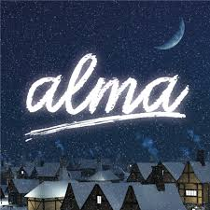 | 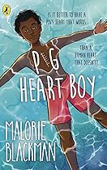  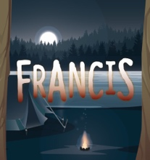 | 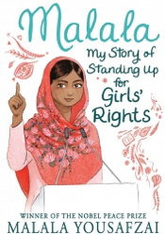 | 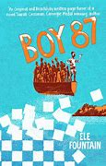  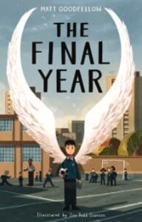
Abomination  Beyond The Lines | What A Wonderful World: Be Inspired to Care For Our Planet  The Promise | Everest  Alma | Pig Heart Boy  Francis | Malala: My Story of Standing Up For Girls Rights | Boy 87  The Final year
Books for Whole class guided reading
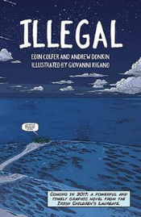  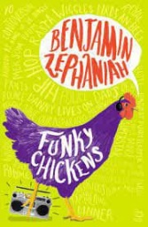 | 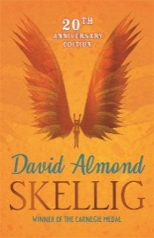  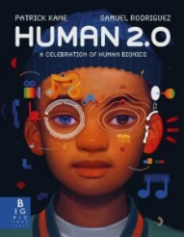 | 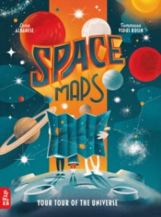  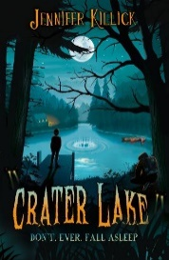 | 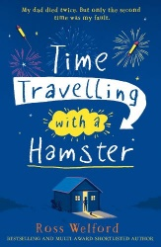 | 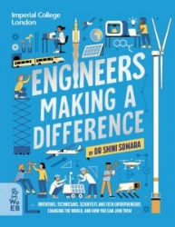  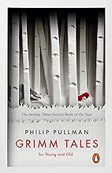 | 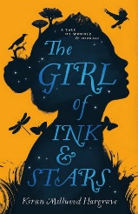
Illegal  Funky Chickens | Skellig  Human 2.0 | Space Maps  Crater Lake | Time Travelling Hamster  Everest | Grimm Tales  Engineers Making a Difference | The Girl of Ink and Stars  The Final Year
Poetry
Poetry to write | Poetry to perform | Poetry to write | Poetry to perform | Poetry to listen to | Poetry to read
Imagery poetry based on the City of Silence | The Highwayman by Alfred Noyes | Free form poem | Daffodils by William Wordsworth | Collected Poems for Children by Charles Causley | If by Rudyard Kipling

