Autumn 1 | Autumn2 | Spring 1 | Spring 2 | Summer 1 | Summer 2
Inspiring Books used for writing
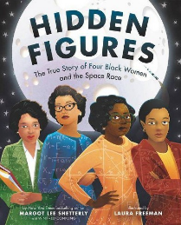  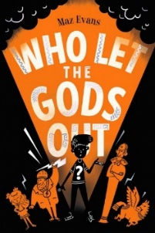 | 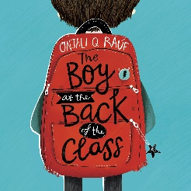  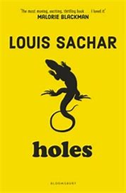 | 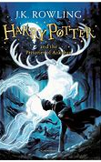  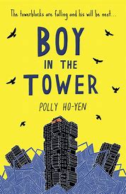 | 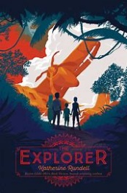  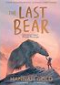 | 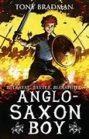  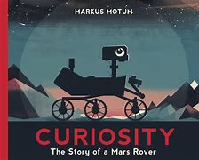 | 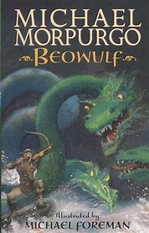  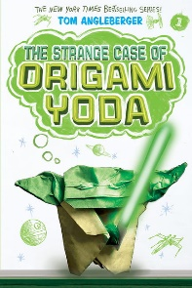
Who let the Gods out?  Hidden Figures | The Boy at the Back of the Class  Holes | Harry and the Prisoner of Azkaban  Boy in the Tower | The Explorer  The Last Bear | Anglo Saxon Boy  Curiosity | Beowulf  The Strange Case of Origami Yoda
Books for Whole class guided reading
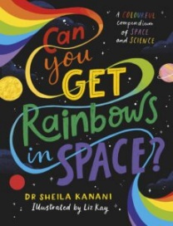  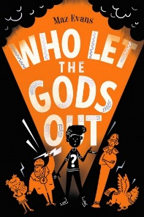 | 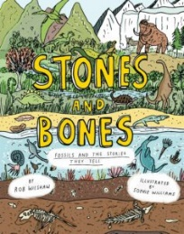  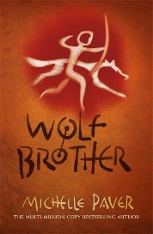 | 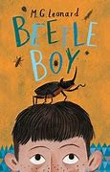  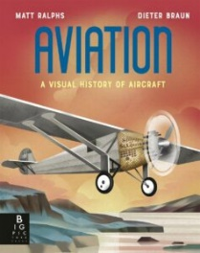 | 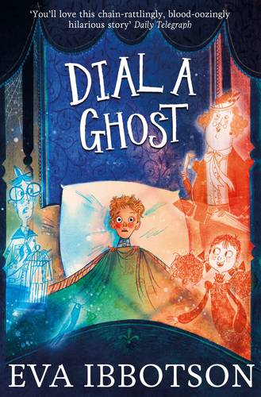  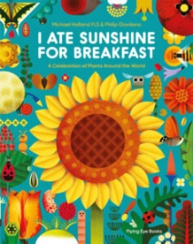 | 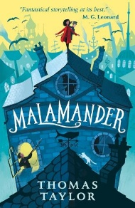  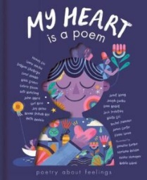 | 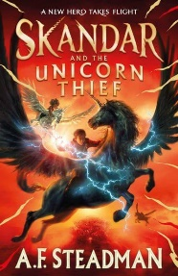  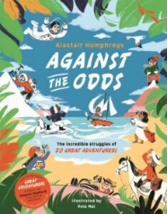
F: Who let the Gods out?  NF: Can you get Rainbows in Space? | F: Wolf Brother  NF: Stones and Bones | F: Beetle Boy  NF: Aviation, A visual History of Aircraft | F: Dial a Ghost  NF: I Ate Sunshine for Breakfast | F: Malamander  P: My Heart is a Poem | F: Skandar and the Unicorn Thief  NF: Against the Odds
Poetry
Poetry to listen to | Poetry to perform | Poetry to write | Poetry to write | Poetry to perform | Poetry to listen to
The Puffin Book of Utterly Brilliant Poems | Leisure by William Henry Davies | Reverse Poetry linked to topic | Haiku poetry linked to Kensuke’s Kingdom | Walking with my Iguana by Brian Moss | This Rock That Rock by Dom Conlon and Viviane Schwarz

