Autumn 1 | Autumn2 | Spring 1 | Spring 2 | Summer 1 | Summer 2
Inspiring Books used for writing
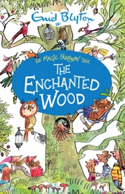  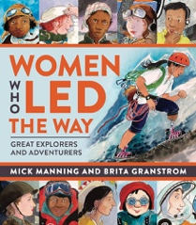 | 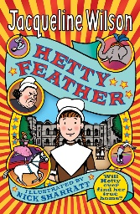  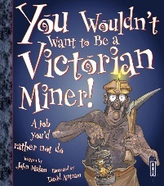 | 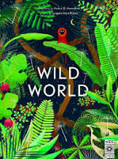  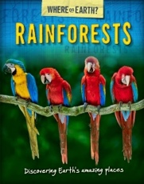 | 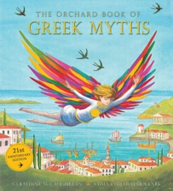  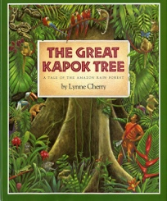 | 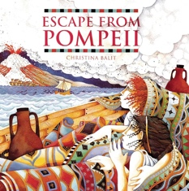 | 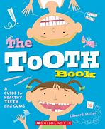  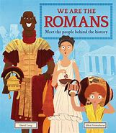
The Enchanted Wood  Women Who Led The Way | You Wouldn’t Want to be a Victorian  Hetty Feather | Wild World  Where on Earth Rainforests | Orchard Greek Myths  The Great Kapok Tree | Orchard Greek Myths  Escape From Pompeii | The Tooth Book  We are the Romans: Meet the people behind the history
Books for Whole class guided reading
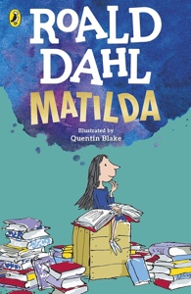  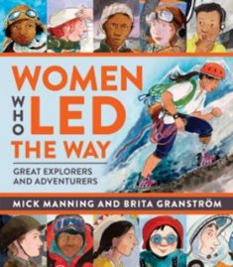 | 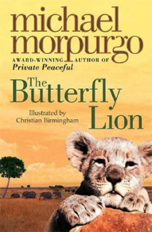  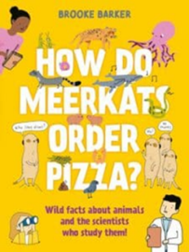 | 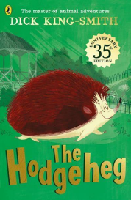  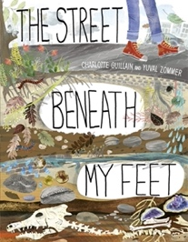 | 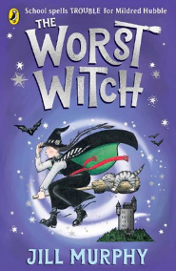  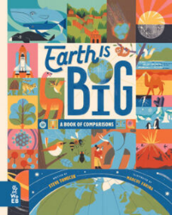 | 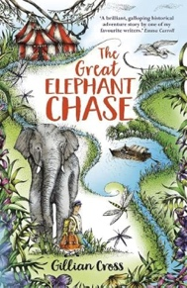  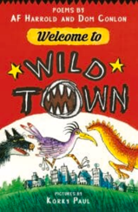 | 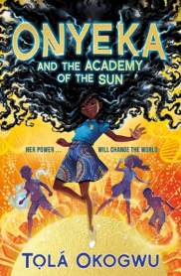  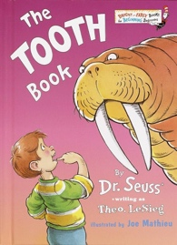
F: Matilda  NF: Women Who Led the Way | F: The Butterfly Lion  NF: How do Meerkats Order Pizza? | F: The Hodgeheg  NF: The Street Beneath My Feet | F: The Worst Witch  NF: Earth is Big | F: The Great Elephant Chase  P: Welcome to Wild Town | F: Onyeka  NF: The Tooth Book
Poetry
Poetry to listen to | Poetry to perform | Poetry to read | Poetry to listen to | Poetry to write | Poetry to write
A year full of poems by Harrison Clark | Chocolate Cake by Michael Rosen | Child’s Song in Spring by E. Nesbitt | Where Zebras go by Sue Hardy Dawson | Acrostic poem based on Journey to the River Sea | A Haiku poem based on Once Upon a Raindrop

