Autumn 1 | Autumn2 | Spring 1 | Spring 2 | Summer 1 | Summer 2
Inspiring Books used for writing
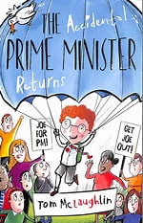  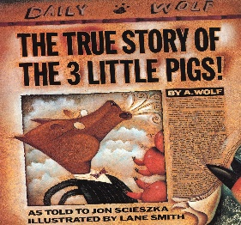 | 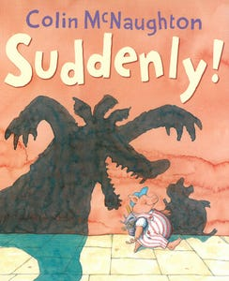  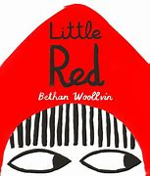 | 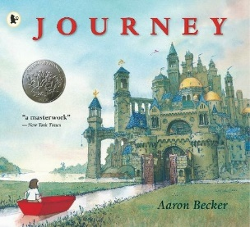  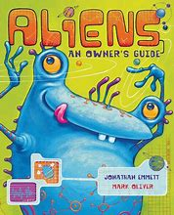 | 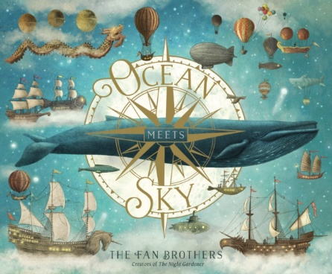 | 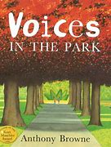  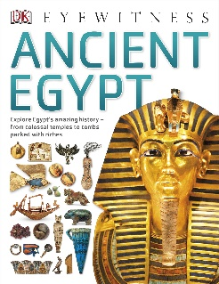 | 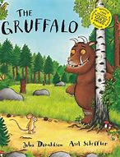  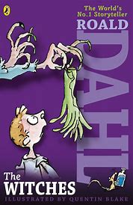
The Accidental Prime Minister  The True Story of the 3 Little Pigs | Suddenly  Little Red | Journey  Aliens – An Owner’s Guide | Ocean Meets Sky | Ancient Egypt  Voices in the Park | The Witches  The Gruffalo
Books for Whole class guided reading
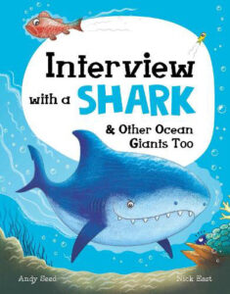  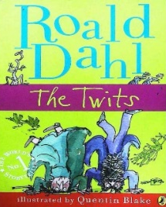 | 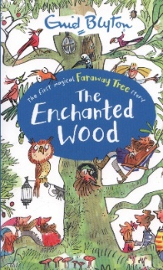  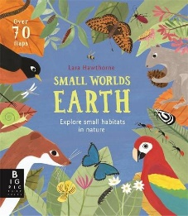 | 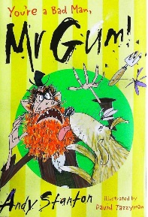  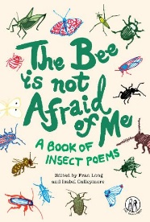 | 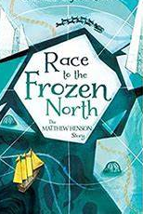  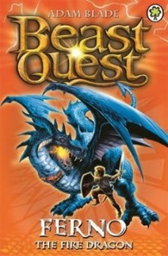 | 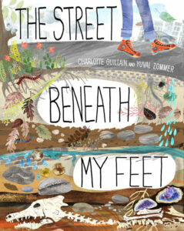  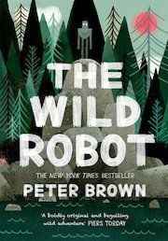 | 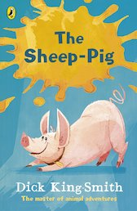  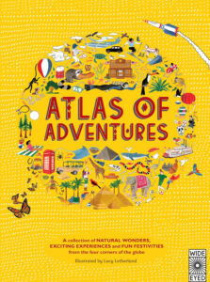
NF: Interview with a Shark  F: The Twits | F: The Enchanted Wood  NF: Small Worlds - Earth | F: You’re a Nasty Man Mr Gum  P: The Bee is not Afraid of Me | NF: Race to the Frozen North  F: Beast Aquest - Ferno | F: The Wild Robot  NF: The Street Beneath My Feet | NF: Atlas of Adventures  F: The Sheep Pig
Poetry
Poetry to listen to | Poetry to read | Poetry to perform | Poetry to read | Poetry to listen to | Poetry to perform
Revolting Rhymes by Roald Dahl | The Door by Miroslav Holub | From a Railway Carriage by Robert Louis Stevenson | Slowly by James Reeves | Making Friends with Frankenstein | The Sound Collector by Roger McGough

