Autumn 1 | Autumn2 | Spring 1 | Spring 2 | Summer 1 | Summer 2
Inspiring Books used for writing
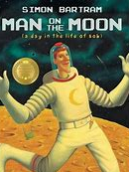  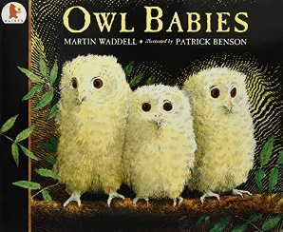 | 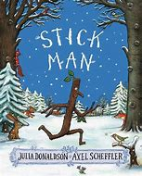  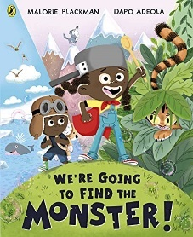 | 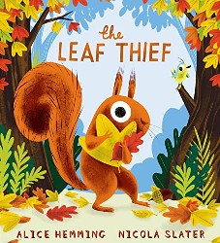  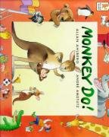 | 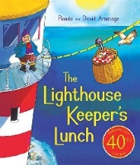  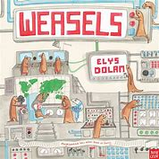 | 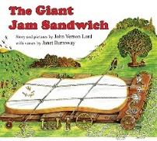  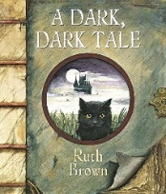 | 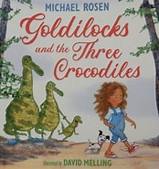  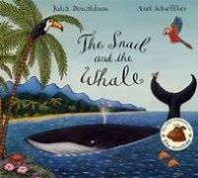
Man on the Moon  Owl Babies | Stick Man  We’re going to Catch a Monster | Leaf Thief  Monkey Do | The Lighthouse Keeper’s Lunch  Weasels | The Giant Jam Sandwich  A Dark Dark Tale | Goldilocks and the 3 Crocodiles  The Snail and the Whale
Talking through stories books
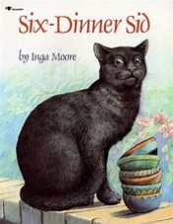  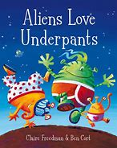 | 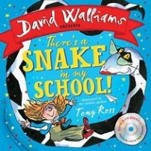  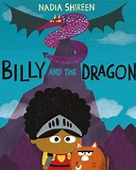 | 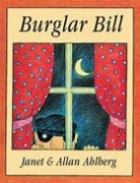  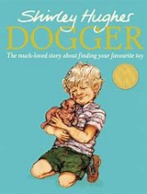 | 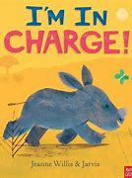  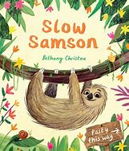 | 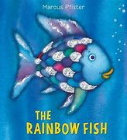  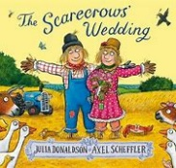 | 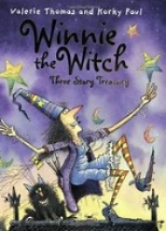  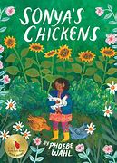
Poetry
Poetry to listen to | Poetry to read together | Poetry to perform | Poetry to listen to | Poetry to read together | Poetry to perform
Smile Out Loud by Joseph Coelho & Daniel Gray Bennet | Spaghetti Spaghetti by Jack Prelutsky | Water by Shirley Hughes | The Puffin Book of Fantastic Poems | Please do not Feed the Animals by Robert Hull | Snowball by Shel Silverstein

