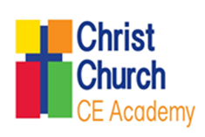

RE Policy

Curriculum Intent
At Enhance Academy Trust, we want all our children to gain the experiences they need to thrive in today’s ever-changing global landscape. As we serve our local communities, it is important for us to not only focus on our area and what makes us unique, but also to provide experiences for pupils beyond those available within our community in order for us to support them in becoming global citizens of the future. In order to achieve this, our Christian vision is at the heart of all that we do. This vision shapes the choices we make when planning and delivering learning experiences for our pupils.
The purpose of religious education in schools is to enable each child and young person to gain knowledge and understanding of Christianity, other religions and worldviews, to learn to show respect for and build bridges between different beliefs and practices, people of different faiths and life stances, and to contribute towards their own spiritual, moral, social and cultural development.

Religious education plays an important and unique role in each child’s and young person’s education enabling them to understand their spiritual identity, to adhere to moral values and to learn to play their role in promoting community cohesion and inclusion in our increasingly diverse society.

Curriculum Content
The curriculum is a trust-wide scheme written by RE specialists. This was implemented in September 2024. The subject follows a spiral curriculum to allow children to revisit key themes and substantive concepts as they progress through each academic year. The curriculum reflects the Christian vision and is taught through the use of the Big Frieze for continuity across school. Each unit of work is put into one of three categories; Understanding Christianity (UC), Thematic (where children compare and contrast different perspectives) or World Religions.

Vocabulary is taught in every RE lesson to allow children to articulate, debate and question their understanding. The overarching vocabulary taught in each lesson is topic specific to ensure that children can use correct terms when explaining their understanding.

At the start and end of every lesson, there is a retrieval section. This allows children to build upon the knowledge they have learnt in the previous lesson, term or academic year.

Curriculum Implementation
At Christ Church CE Academy, RE is taught once a week in Years 1-6. Some children with SEND access history through specialist provision in Rainbows rather than in the main class. In Early Years, children will encounter Christianity and other faiths, as part of their growing sense of self, their own community and their place within it. The religious lenses are also introduced in EYFS and continue throughout school; special people, places, stories etc.

All classes have a RE working wall which displays key vocabulary and knowledge children can refer to. Classes also have the Big Frieze displayed in their classroom for reflection and for teachers to make frequent reference to. There are also several whole-school RE displays around the building depicting world religions and children’s contributions and interpretations of the Big Frieze.

This table shows the time periods and substantive concepts focussed upon in each unit.
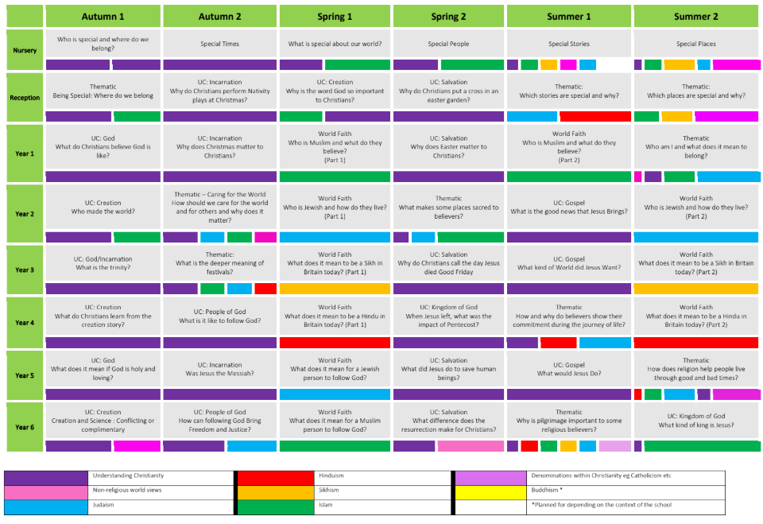

Curriculum Impact
Pupil voice has demonstrated that children are able to recall key facts and some are able to deepen their thinking through links to their own beliefs. They are all able to refer to the knowledge organisers at the start of each unit to support their discussion of the topic. They express that they enjoy RE and they are proud of their work. Children have become far more confident when speaking about RE.
Staff demonstrate strong subject knowledge in lessons and make adaptations to their lessons to ensure that all are able to access their learning. Work in books demonstrates high expectations overall and a range of activities used to record learning.

Assessment Information

The final lesson of each unit is an open-book assessment. Teachers can use the results of these assessments alongside teacher observations when inputting attainment.

Teachers use formative assessment in all lessons through targeted questioning and live marking. They will also use the retrieval sessions at the start of each lesson to establish pupil understanding.

The history leader has provided teachers with impact indicator questions as a more direct way of establishing pupil understanding. The attainment of each child is recorded on a school-wide assessment proforma at the end of each half-term of RE. Teachers will identify barriers to learning and areas for revisiting where children have knowledge gaps.

