Progression of Skills at Christ Church CE Academy
At Christ Church CE Academy, we are committed to providing a broad, balanced, and inspiring curriculum that nurtures the whole child. As part of this commitment, we use the Kapow Primary programme. Kapow Primary’s progression of skills ensure that learning is clearly sequenced, well-structured, and continually builds upon prior knowledge. This progression framework supports our vision of developing confident, curious, and capable learners who flourish academically, socially, and emotionally.
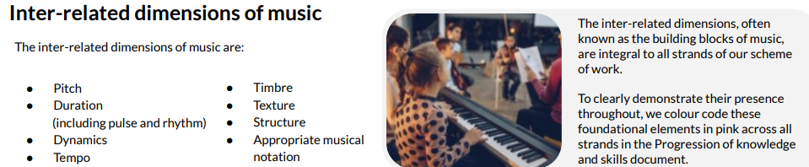
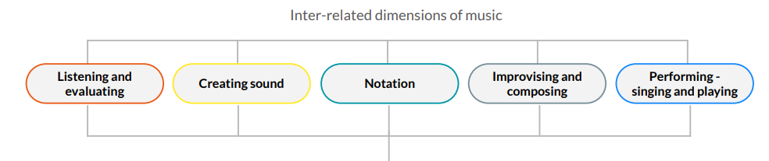
Kapow’s carefully mapped skill progression allows us to deliver high-quality teaching across all subjects, with clear end goals and developmental steps that are tailored to each year group. It ensures that every child at Christ Church CE Academy has the opportunity to revisit, embed, and extend their learning as they journey through the curriculum. This consistent approach supports both teaching staff and pupils, promoting a shared understanding of expectations and excellence at every stage. Music is split into five key areas that are essential to understanding music and the way it is taught.
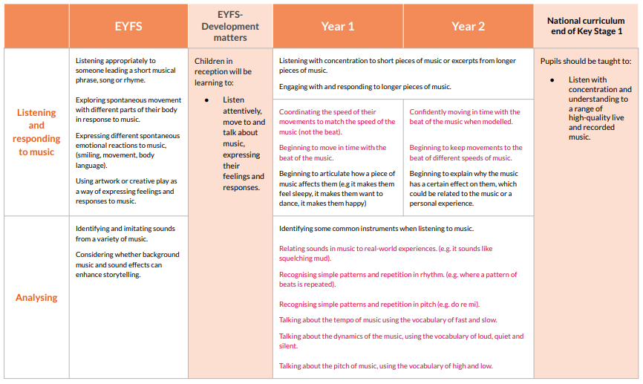
Progression of skills: Listening and Evaluating
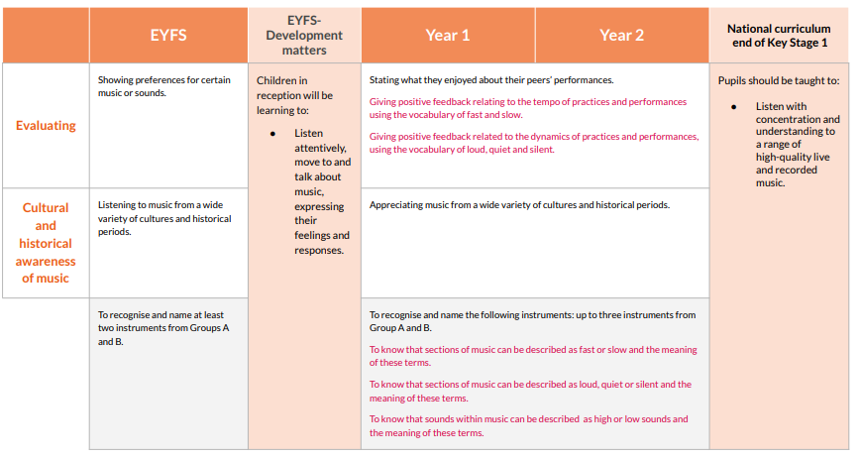
Progression of skills: Listening and Evaluating

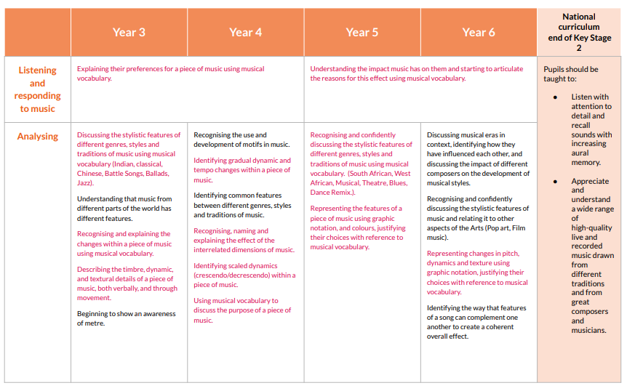
Progression of skills: Listening and Evaluating
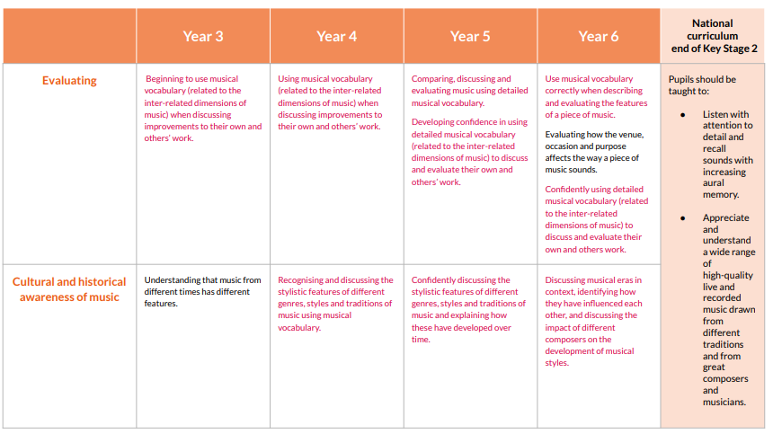
Progression of skills: Listening and Evaluating

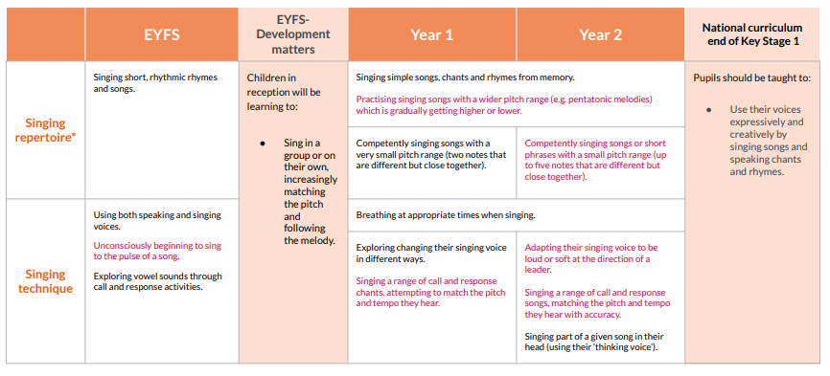
Progression of skills: Creating Sound

Progression of skills: Creating Sound

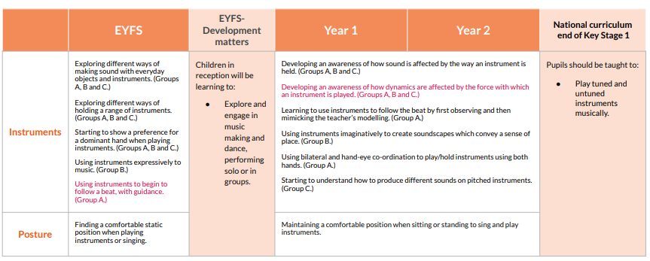

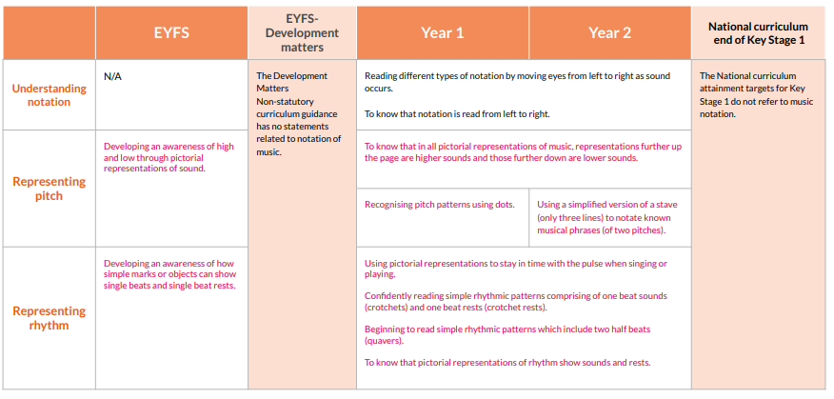
Progression of skills: Notation

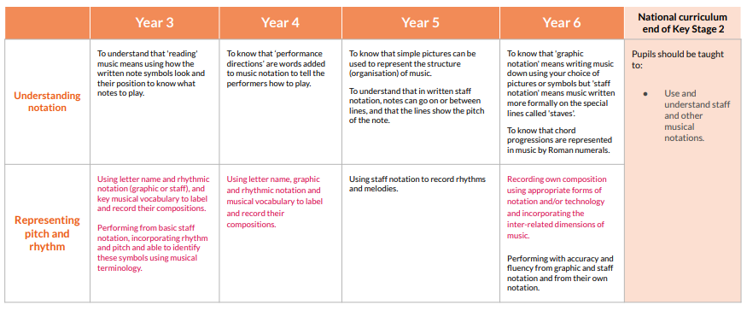
Progression of skills: Notation

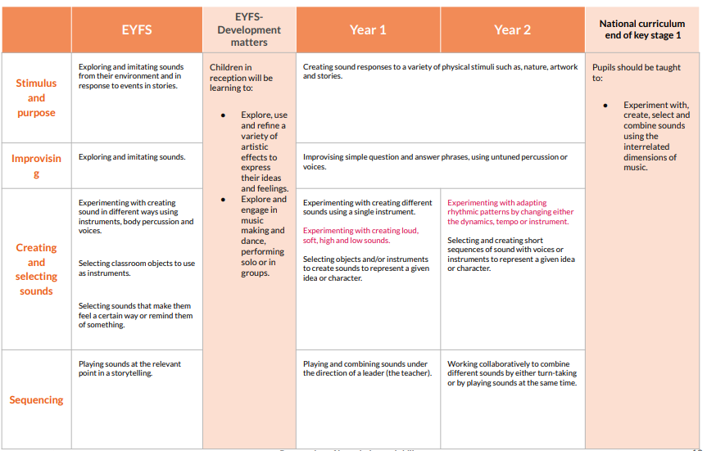
Progression of skills: Improvising

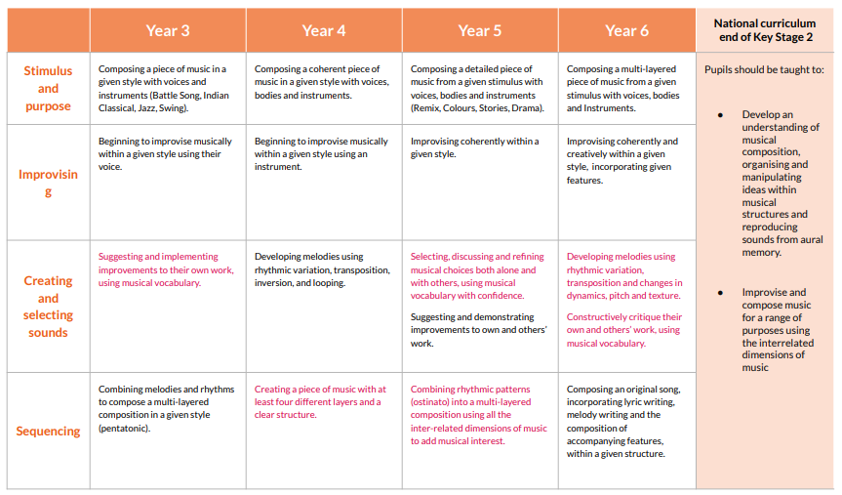
Progression of skills: Improvising

Progression of skills: Performing
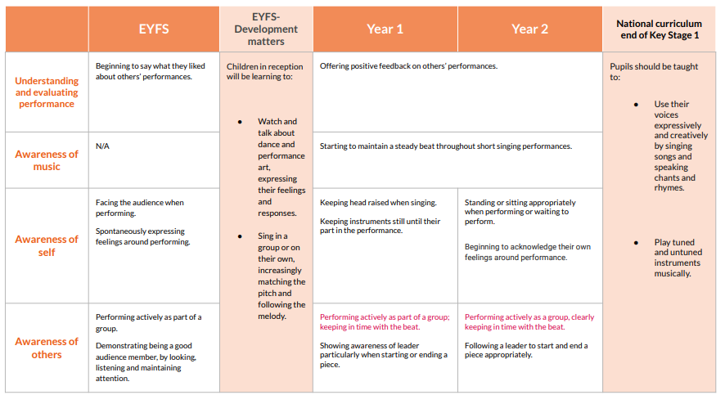
Progression of skills: Performing
