

Music Policy

Intent

At Christ Church CE Academy, our music curriculum is designed to inspire creativity, self-expression, and a lifelong love of music. We believe that music is a powerful tool for building community, nurturing well-being, and celebrating the diverse world that we live in. Through the use of Kapow Primary’s Music scheme, we provide a carefully sequenced, progressive curriculum that enables every child to develop their musical knowledge, skills, and confidence to become confident performers, composers and listeners. Children will develop the musical skills of singing, playing tuned and untuned instruments, improvising and composing music, and listening and responding to music.
We aim to ensure that all pupils:
- Develop a secure understanding of the interrelated dimensions of music.
- Learn to perform, compose, listen, respect and appraise across a wide variety of musical genres, traditions, communities and historical periods.
- Gain the ability to express themselves creatively and spiritually through music.
- Build resilience, teamwork, decision making, presentation and performance skills, and self-confidence through performance opportunities.
- Experience the joy and inclusivity of music-making as part of a community.
These skills are vital to children’s development as learners and have a wider application in their general lives outside and beyond school. Kapow Primary’s Music scheme of work enables pupils to meet the end of key stage attainment targets outlined in the National curriculum and the aims of the scheme align with those in the National curriculum.
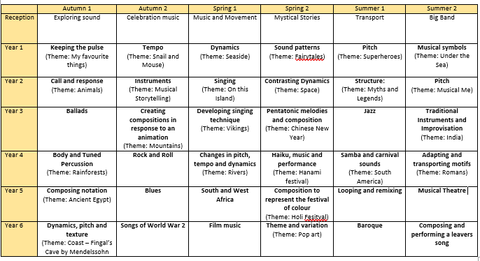
Overview of Long Term Plan:

Implementation
Music is taught weekly as a discrete subject using Kapow Primary’s specialist-designed scheme, which aligns with the National Curriculum and supports non-specialist teachers with high-quality planning and resources. Lessons are engaging, practical, and inclusive, ensuring all learners can access the curriculum and progress at their own level. Individual strands of music are interlinked and threaded through lessons to create engaging and enriching experiences.
The five key strands are:
- Listening and evaluating
- Creating sound
- Notation
- Improvising and composing
- Performing
Key features of our music implementation include:
- A clear progression of knowledge and skills from EYFS to Year 6.
- Opportunities for pupils to sing, play tuned and untuned instruments, compose, improvise, and perform.
- Regular use of body percussion, classroom instruments, and digital tools to support varied learning experiences.
- Listening to and appraising a wide range of music, with opportunities to discuss, evaluate, and respond.
- Links to cultural and Christian events through music in worship, performances, and celebrations.
- Extra-curricular opportunities such as choir, musical performances, and links with the wider community and local church.

Impact
By the time pupils leave Christ Church CE Academy, they will have developed a secure and broad understanding of music. They will be confident performers, composers, and listeners who can articulate their thoughts and opinions about music using appropriate terminology. Our children will leave us with an appreciation of music from different cultures and traditions, and a sense of how music can bring people together, express identity, and reflect on faith. They will be able to understand the various ways in which music can be written down to support both performing and composing activities. Our children will be able to demonstrate and articulate an enthusiasm for music and be able to identify their own personal musical preferences.
The impact of our music curriculum is monitored through:
- Pupil voice and performance assessments.
- Teacher observations and formative assessment opportunities in each unit.
- Evidence of progression in musical vocabulary and skills.
- Participation in performances and wider musical opportunities.
Music at Christ Church CE Academy enables every child to discover their own musical voice and to experience the joy, connection, and creative freedom that music brings.

