
Computing Policy
At Christ Church Academy, the growth and development of children and adults is central to everything we do. As a church school, we aim to serve and take care of our community by providing an education which inspires every child to be the best they can be. This is within a framework which is rooted in distinctive Christian beliefs and values whilst embracing diversity, respecting other faiths and worshipping together. We encourage an understanding of the meaning and significance of faith and promote Christian values through the experiences we offer to all our school community.

Intent
Christ Church Academy aims to instil a sense of enjoyment around using technology and to develop children’s appreciation of its capabilities and the opportunities technology offers to create, manage, organise and collaborate. Tinkering with software and programs forms a part of the ethos of the scheme as we want to develop pupils’ confidence when encountering new technology, which is a vital skill in the ever evolving and changing landscape of technology. Through our curriculum, we intend for pupils not only to be digitally competent and have a range of transferable skills at a suitable level for the future workplace, but also to be responsible online citizens. We intend to equip children for life in the digital world, including developing their understanding of appropriate online behaviour, copyright issues, being discerning consumers of online information and healthy use of technology.

Aims of the Teaching of Computing
The school’s aims are to:
- provide a relevant, challenging and enjoyable curriculum for computing;
- meet the requirements of the National Curriculum Programmes of Study for Computing;
- use computing as a tool to enhance learning throughout the curriculum;
- respond to new developments in technology;
- equip pupils with the confidence and capability to use computing throughout their later life;
- enhance learning in other areas of the curriculum using computing;
- develop the understanding of how to use computing safely and responsibly.
The National Curriculum for Computing aims to ensure that all pupils:
- can understand and apply the fundamental principles of computer science, including logic, algorithms, data representation, and communication;
- can analyse problems in computational terms, and have repeated practical experience of writing computer programs in order to solve such problems;
- can evaluate and apply information technology, including new or unfamiliar technologies, analytically to solve problems.
- are responsible, competent, confident and creative users of Information and Communication Technology.

Teaching and Learning Overview
Early Years Foundation Stage:
It is important in the Early Years Foundation Stage to give children a broad, play based experience of ICT in a range of contexts, including outdoor play. Computing is not just about computers. Early Years learning environments should feature computing scenarios based on experience in the real world, such as in role play. Children gain confidence, control and language skills through opportunities to ‘paint’ on the whiteboard or drive a remote-controlled toy. Outdoor exploration is an important aspect, supported by computing toys. Recording devices can support children to develop their communication skills. This is especially useful for children who have English as an additional language.

By the end of Key Stage 1 pupils should be taught to:
- understand what algorithms are, how they are implemented as programs on
- digital devices, and that programs execute by following a sequence of
- instructions;
- write and test simple programs;
- use logical reasoning to predict the behaviour of simple programs in
- computing;
- organise, store, manipulate and retrieve data in a range of digital formats;
- communicate safely and respectfully online, keeping personal information
- private, and recognise common uses of information technology beyond
- school.
By the end of Key Stage 2 pupils should be taught to:
- design and write programs that accomplish specific goals, including controlling or simulating physical systems; solve problems by decomposing them into smaller parts;
- use sequence, selection, and repetition in programs; work with variables and various forms of input and output; generate appropriate inputs and predicted outputs to test programs;
- use logical reasoning to explain how a simple algorithm works and to detect and correct errors in algorithms and programs;
- understand computer networks including the Internet; how they can provide multiple services, such as the world-wide web; and the opportunities they offer for communication and collaboration;
- describe how internet search engines find and store data; use search engines effectively; be discerning in evaluating digital content; respect individuals and intellectual property; use technology responsibly, securely and safely;
- select, use and combine a variety of software (including internet services) on a range of digital devices to accomplish given goals, including collecting, analysing, evaluating and presenting data and information.
- use technology safely, respectfully and responsibly; recognise acceptable/unacceptable behaviour; identify a range of ways to report concerns about content and contact.

Curriculum Delivery
At Christ Church Academy, we follow the Kapow Primary Computing scheme of work, which enables pupils to meet the end of key-stage attainment targets outlined in the national curriculum. The Kapow Primary scheme of work is designed with three strands which run throughout: computer science, information technology and digital literacy.
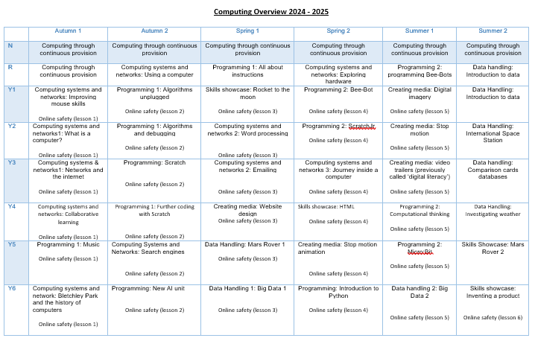

Assessment and record keeping
The impact of the computing curriculum can be constantly monitored through both formative and summative assessment opportunities. Each lesson includes guidance (provided by Kapow Primary) to support teachers in assessing pupils against the learning objectives and each unit has a unit quiz and knowledge catcher which can be used at the start and/or end of the unit. After the implementation of our computing curriculum, children should leave school equipped with a range of skills to enable them to succeed in their secondary education and be active participants in the ever-increasing digital world.

The expected impact following the Kapow Primary Computing scheme of work is that children will:
- Be critical thinkers and able to understand how to make informed and appropriate digital choices in the future.
- Understand the importance that computing will have going forward in both their educational and working life and in their social and personal futures.
- Understand how to balance time spent on technology and time spent away from it in a healthy and appropriate manner.
- Understand that technology helps to showcase their ideas and creativity. They will know that different types of software and hardware can help them achieve a broad variety of artistic and practical aims.
- Show a clear progression of technical skills across all areas of the National curriculum – computer science, information technology and digital literacy.
- Be able to use technology both individually and as part of a collaborative team.
- Be aware of online safety issues and protocols and be able to deal with any problems in a responsible and appropriate manner.
- Have an awareness of developments in technology and have an idea of how current technologies work and relate to one another.
- Meet the end of key stage expectations outlined in the National curriculum for Computing.

Monitoring and evaluation
The subject leader is responsible for monitoring the standard of the children’s work and the quality of teaching. This may be through book scrutiny or looking at other data for the subject. The subject leader is also responsible for supporting colleagues in the teaching of computing, for being informed about current developments in the subject, and for providing a strategic lead and direction for the subject in the school.

