
Christ Church C of E Academy

Spoken Language and Oracy Curriculum


Progression in the Four Strands of Oracy
Skill Reception | Nursery | Reception | Year 1 | Year 2 | Year 3 | Year 4 | Year 5 | Year 6
  Physical |  | Speak with  appropriate  volume.  Look at who is  talking and who  you are talking  to.  Begin to use  gestures to  support delivery  meaning e.g.  pointing at parts  of a plant they  are discussing | Speak clearly  and confidently  in a range of  contexts.  Use appropriate  tone of voice in  the right context  e.g. To project  their voice to a  large audience.  Continue to use  gesture to  support delivery  e.g. pointing at  parts of a plant  they are  discussing | Speak clearly  and confidently  with appropriate  volume and  pace in a range  of contexts.  Gestures start to  become  increasingly  natural to  support speech  e.g. gesturing  towards  someone if  referencing their  idea.  Use body  language to  show active  listening and  support meaning  when speaking  e.g. nodding  along, facial  expressions | Deliberately  selects gestures  that support the  delivery of ideas  e.g. gesturing  towards  someone if  referencing their ideas.  Deliberately  varies tone of  voice to convey  meaning e.g.  speaking  authoritatively  during an expert  talk.  Consider position  and posture  when addressing  an audience | Deliberately  select movement  and gesture  when addressing  an audience.  To use pauses  for effect in  presentational  talk e.g. when  telling an  anecdote or  joke.  Use the  appropriate  tone of voice in  the right context  e.g. speaking  calmly when  resolving an  issue in the  playground | Deliberately  varies tone of  voice in order to  convey meaning  e.g. speaking  authoritatively  during an expert  talk, or speaking  with pathos when  telling a sad  part of a story.  Project their  voice to a large  audience.  Gestures  become  increasingly  natural.  Consciously  adapt tone,  pace and  volume of voice  within a single  context | Speak fluently in  front of an  audience.  Have a stage  presence.  Consciously  adapt, tone,  pace and volume  of voice

Skill Reception | Nursery | Reception | Year 1 | Year 2 | Year 3 | Year 4 | Year 5 | Year 6
  Linguistic |  | Use talk in play  to practice new  vocabulary e.g.  lighter, heavier.  Begin to speak  in sentences  joining phrases  with words such  as ‘if, because,  so, could, but’ | Speak in sentences  using joining  phrases to link  ideas.  Using vocabulary  appropriately  specific to the  topic in hand e.g.  lighter/heavier  rather than bigger  and smaller.  Take opportunities  to try out new  language, even if  it is not always  correctly used.  Use sentence stems  to link to other’s  ideas in group  discussion e.g. ‘I  agree with…  because...’ ‘linking  to…’  Use conjunctions  to organise and  sequence ideas  e.g. firstly,  secondly, finally | Speaking in  sentences using  joining phrases  to create longer  sentences.  Adapt how to  speak in  different  situations  according to the  audience e.g.  asking questions  of a museum  curator or  having a  conversation with  a visitor to the  classroom.  Use sentence  stems to signal  when they are  building or  challenging  others’ ideas in  group’ | Be able to use  specialist  language to  describe their  own and others’  talk.  Use specialist  vocabulary e.g.  speak like an  archaeologist.  Make precise  language choices  e.g. instead of  describing a  cake as ‘ice’  using  ‘delectable’ | Carefully  consider the  words and  phrasing they  use to express  their ideas and  how this supports  the purpose of  the talk e.g. to  persuade or to  entertain. | Use an  increasingly  sophisticated  range of  sentence stems  with fluency and  accuracy to cite  evidence and  ask probing  questions.  Consider the  words and  phrases used to  express their  ideas and how  this supports the  purpose of talk. | Use and innovate an increasingly sophisticated range of sentence stems with fluency and accuracy.  Vary sentence structures and length for effect when speaking.  Be comfortable using idioms and expressions

Skill Reception | Nursery | Reception | Year 1 | Year 2 | Year 3 | Year 4 | Year 5 | Year 6
  Cognitive |  | Use ‘because’ to  develop their  ideas.  Make relevant  contributions that  match what has  been asked.  Ask simple  questions.  Describe events  that have  happened to  them in detail. | Offer reasons  for their  opinions.  Recognise when  they haven’t  understood  something and  ask a question.  Disagree with  someone else’s  opinion politely.  Explain ideas  and events in  chronological  order | sk questions to  find out more  about a subject.  Build on others’  ideas in  discussions.  Make  connections  between what  has been said  and their own  and others’  experiences. | Offer opinions that aren’t their own e.g. taking on the role of …  Begin to reflect on discussions and their own oracy skills and identify areas of strength and areas to improve through the introduction of  Talk Detectives.  Reach shared agreement in discussions. | Give supporting  evidence e.g.  citing a text  (using sentence  stems) a previous  example or a  historical event.  Ask probing  questions.  Reflect on their  own oracy skills  and identify  areas of strength  and areas to  improve and  begin to set own  targets. | Draw upon  knowledge of  the world to  support their  own point of  view and  explore  different  perspectives.  To be able to  give supporting  evidence e.g.  citing a text, a  previous  example or a  historical event  Identify when a  discussion is  going off topic  and be able to  bring it back on  track with  support and use  of sentence  stems e.g. That  might be true,  however what  do you think  about …. | Construct a detailed argument or complex narrative.  Spontaneously respond to and offer increasingly complex questions, citing evidence where appropriate.  Reflect on their own and others’ oracy skills and identify how to improve.

Skill Reception | Nursery | Reception | Year 1 | Year 2 | Year 3 | Year 4 | Year 5 | Year 6
  Social and Emotional |  | Look at someone  who is speaking  to them.  Wait for a turn.  Taking turns to  speak, when  working in a  group | Listen and  respond  appropriately to  others.  Be willing to  change their  mind based on  what they have  heard.  Begin to  organise group  discussions  independently of  an adult. | Start to develop  an awareness of  audience e.g.  what might  interest a certain  group.  Start to show  awareness of  others who have  not spoken and  invite them into  the discussion  e.g. saying their  name, asking  them a question,  turning to them.  Recite/deliver  short preprepared  material to an  audience. | Speak with  confidence in  front of an  audience.  Begin to  recognise  different roles  within group talk  e.g. chairperson.  Adapt the  content of their  speech for a  specific  audience. | Use more natural  and subtle  prompts for turn  taking.  Start to develop  empathy with an  audience.  Consider the  impact of their  words on others  when giving  feedback. | Listen for  extended  periods of time  including notetaking, drawing  visual.  Adapt the  content of their  speech for a  specific audience  e.g. use of  humour.  Speak with flair  and passion. | Use humour  effectively.  Begin to be able  to read a room  or a group and  take action  accordingly e.g.  if everyone looks  disengaged,  moving on or  changing topic,  or if people look  confused  stopping

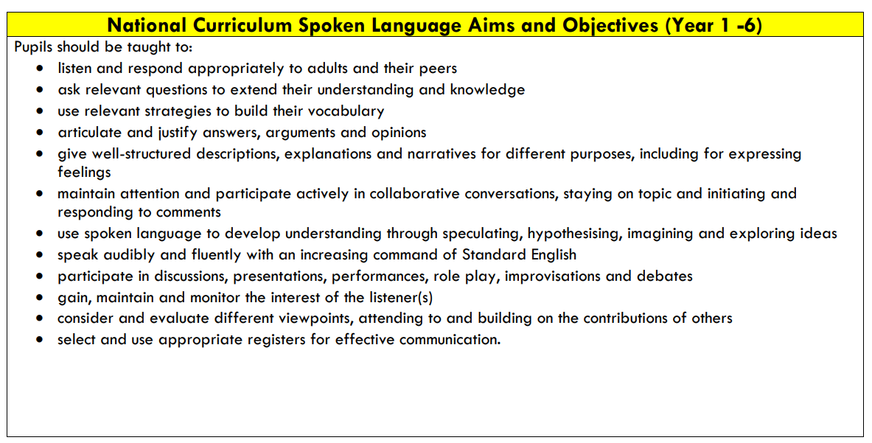
Oracy Curriculum Overview

Year 1
Keynote from National Curriculum for Year 1 Teachers: Teachers should ensure that their teaching develops pupils’ oral vocabulary as well as their ability to understand and use a variety of grammatical structures, giving particular support to pupils whose oral language.
Autumn | Spring | Summer
Physical Oracy:  • Speak clearly and confidently in a range of  contexts.  • Use appropriate tone of voice in the right  context e.g. To project their voice to a large  audience.  • Continue to use gesture to support delivery  e.g. pointing at parts of a plant they are  discussing.  Linguistic Oracy:  • Speak in sentences using joining phrases to  link ideas.  • Using vocabulary appropriately specific to  the topic  • Take opportunities to try out new language,  even if it is not always correctly used.  • Use sentence stems to link to other’s ideas in group discussion | Cognitive Oracy:  • Offer reasons for their opinions  • Recognise when they haven’t understood  something and ask a question  • Disagree with someone else’s opinion  politely  • Explain ideas and events in chronological  order | Social & Emotional Oracy:  • Listen and respond appropriately to others  • Be willing to change their mind based on  what they have heard  • Begin to organise group discussions  independently of an adult

Year 2
Keynote from National Curriculum for Year 2 Teachers: The sooner that pupils can read well and do so frequently, the
sooner they will be able to increase their vocabulary, comprehension and their knowledge across the wider Curriculum.
Autumn | Spring | Summer
Physical Oracy:  Speak clearly and confidently with  appropriate volume and pace in a range of  contexts.  •Gestures start to become increasingly  natural to support speech e.g. gesturing  towards someone if referencing their idea.  •Use body language to show active listening  and support meaning when speaking e.g.  nodding along, facial expressions  Linguistic Oracy:  • Speaking in sentences using joining phrases  to create longer sentences. Through  encouragement to use conjunctions and  sentence stems in speech and writing.  • Adapt how to speak in different situations  according to the audience.  • Use sentence stems to signal when they are  building or challenging others’ ideas in  groups. | Cognitive Oracy:  •Ask questions to find out more about a  subject  • Build on others’ ideas in discussions  • Make connections between what has been  said and their own and others’ experience | Social & Emotional Oracy:  • Start to develop an awareness of audience  e.g. what might interest a certain group  • Start to show awareness of others who have  not spoken and invite them into the  discussion e.g. saying their name, asking  them a question, turning to them  • Recite/deliver short preprepared material  to an audience

Year 3
Keynote from National Curriculum for Year 3 Teachers: In years 3 and 4, pupils should become more familiar with
and confident in using language in a greater variety of situations, for a variety of audiences and purposes, including
through drama, formal presentations and debate
Autumn | Spring | Summer
Physical Oracy:  • Deliberately selects gestures that  support the delivery of ideas e.g.  gesturing towards someone if  referencing their ideas.  • Deliberately varies tone of voice in  order to convey meaning e.g. speaking  authoritatively during an expert talk.  • Consider position and posture when  addressing an audience.  Linguistic Oracy:  • Be able to use specialist language to  describe their own and others’ talk.  • Use specialist vocabulary e.g. speak  like an archaeologist.  • Make precise language choices e.g.  instead of describing a cake as ‘nice’  using ‘delectable’ | Cognitive Oracy:  •Offer opinions that aren’t their own  e.g. taking on the role of …  •Begin to reflect on discussions and  their own oracy skills and identify areas of strength and areas to  improve through the introduction of Talk Detectives  • Reach shared agreement in discussions | Social & Emotional Oracy:  • Speak with confidence in front of an  audience  •Begin to recognise different roles  within group talk e.g. chairperson  •Adapt the content of their speech for  a specific audience

Year 4
Keynote from National Curriculum for Year 3 Teachers: In years 3 and 4, pupils should become more familiar with
and confident in using language in a greater variety of situations, for a variety of audiences and purposes, including
through drama, formal presentations and debate
Autumn | Spring | Summer
Physical Oracy:  • Deliberately select movement and  gesture when addressing an audience.  • To use pauses for effect in  presentational talk e.g. when telling an anecdote or joke.  • Use the appropriate tone of voice in  the right context.  Linguistic Oracy:  • Carefully consider the words and  phrasing they use to express their ideas  and how this supports the purpose of  the talk e.g. to persuade or to entertain | Cognitive Oracy:  •Give supporting evidence e.g. citing  a text (using sentence stems) a previous example or a historical  event  • Ask probing questions  • Reflect on their own oracy skills and  identify areas of strength and areas to improve and begin to set own  targets | Social & Emotional Oracy:  • Use more natural and subtle prompts  for turn taking  • Start to develop empathy with an  audience  • Consider the impact of their words on  others when giving feedback

Year 5
Keynote from National Curriculum for Year 5 Teachers: During years 5 and 6, teachers should continue to emphasise
pupils’ enjoyment and understanding of language, especially vocabulary, to support their reading and writing
Autumn | Spring | Summer
Physical Oracy:  • Deliberately varies tone of voice in  order to convey meaning e.g. speaking  authoritatively during an expert talk, or  speaking with pathos when telling a  sad part of a story.  • Project their voice to a large  audience.  • Gestures become increasingly natural.  Linguistic Oracy:  • Use an increasingly sophisticated  range of sentence stems with fluency  and accuracy to cite evidence and ask  probing questions.  • Consider the words and phrases used  to express their ideas and how this  supports the purpose of talk. | Cognitive Oracy:  •Draw upon knowledge of the world  to support their own point of view  and explore different perspectives  • To be able to give supporting evidence e.g. citing a text, a previous example or a historical event  • Identify when a discussion is going  off topic and be able to bring it back  on track with support and use of  sentence stems e.g. That might be  true, however what do you think  about …? | Social & Emotional Oracy:  • Listen for extended periods of time  including notetaking, drawing visual  • Adapt the content of their speech for  a specific audience e.g. use of  humour  • Speak with flair and passion

Year 6
Keynote from National Curriculum for Year 5 Teachers: During years 5 and 6, teachers should continue to emphasise
pupils’ enjoyment and understanding of language, especially vocabulary, to support their reading and writing
Autumn | Spring | Summer
Physical Oracy:  • Speak fluently in front of an  audience.  • Have a stage presence.  • Consciously adapt, tone, pace and  volume of voice.  Linguistic Oracy:  • Use and innovate an increasingly sophisticated range of  sentence stems with fluency and  accuracy.  • Vary sentence structures and length  for effect when speaking.  • Be comfortable using idioms and  expressions. | Cognitive Oracy:  •Construct a detailed argument or  complex narrative  •Spontaneously respond to and offer  increasingly complex questions, citing  evidence where appropriate  • Reflect on their own and others’  oracy skills and identify how to  improve | Social & Emotional Oracy:  • Use humour effectively  • Begin to be able to read a room or a  group and take action accordingly  e.g. if everyone looks disengaged,  moving on or changing topic, or if  people look confused stopping to  take questions

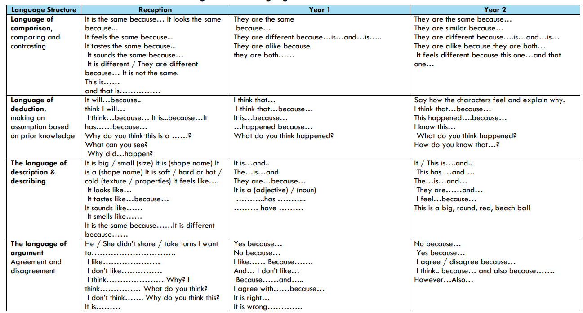
Progression of Sentence Stems in KS1

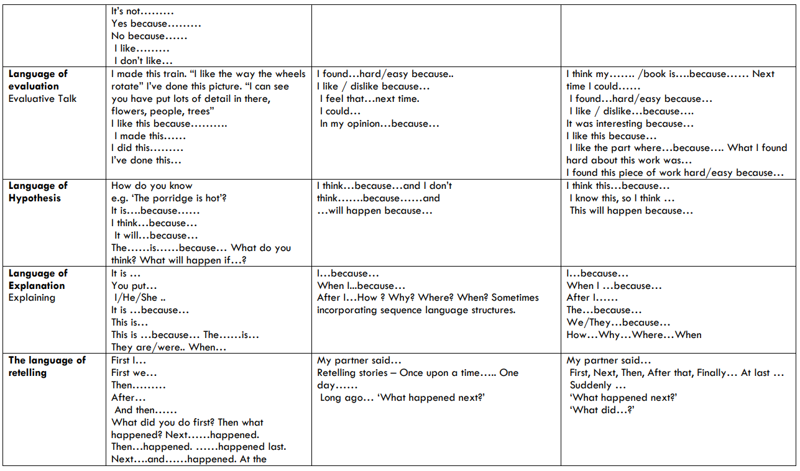

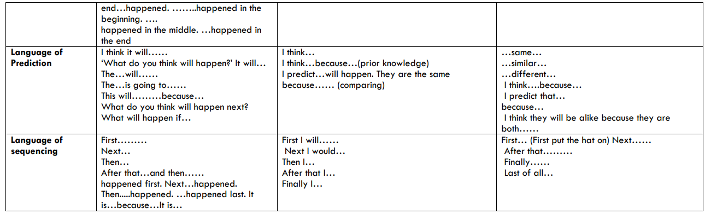

Progression of Sentence Stems in KS2
