Nursery Journey


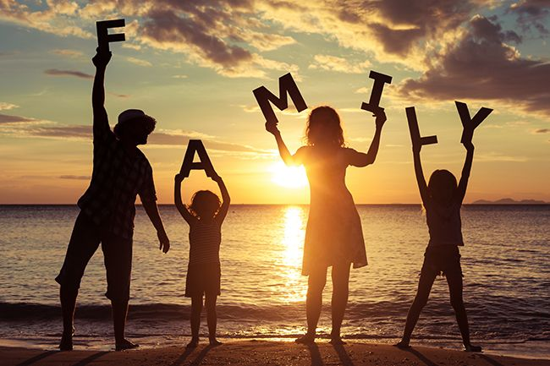
Autumn

Me and My Family
Children will learn about different families and talk about who is in their family.

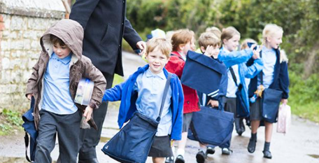
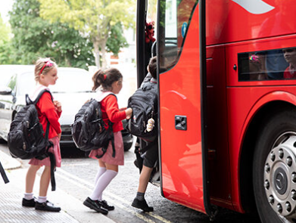
Spring

Travel
Children will learn about travel and talk about how they travel to school.

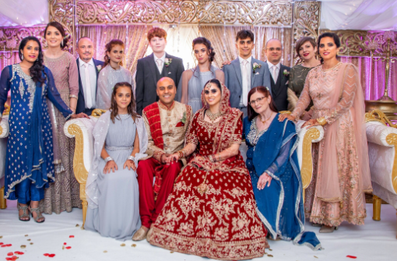

Summer

Celebrations
Children will learn about special celebrations including birthdays and weddings.

Reception Journey
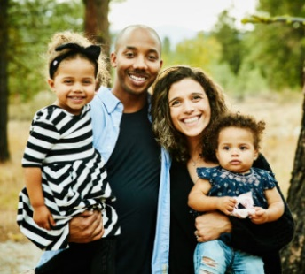
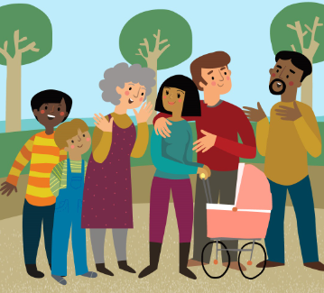
Autumn

My Family & Community
Children will learn about who looks after them in their family and the wider community.

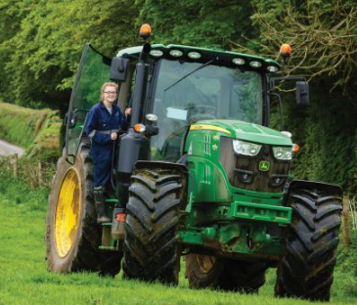
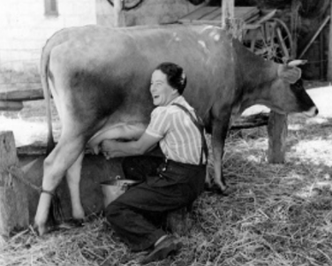
Spring

Now and Then - Jobs
Children will learn about the job of a farmer and how this job has changed over time.


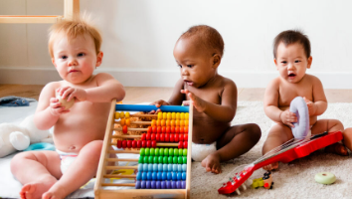
Summer

Changing & Growing
Children will create a timeline showing how they have changed since they were a baby.

Year 1 Journey
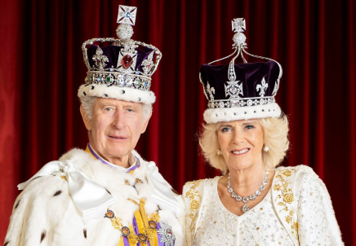
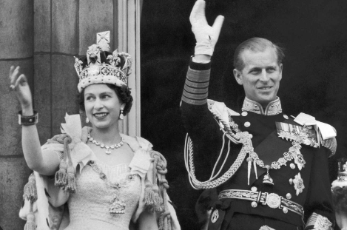
Autumn

The Royal Family
- Enquiry Question – Who are the Royal family and why are they important to Britain?

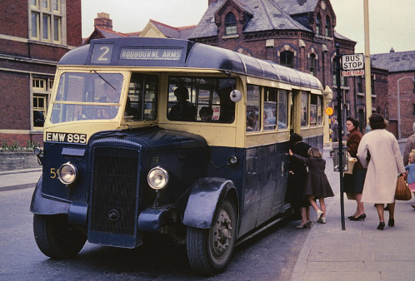
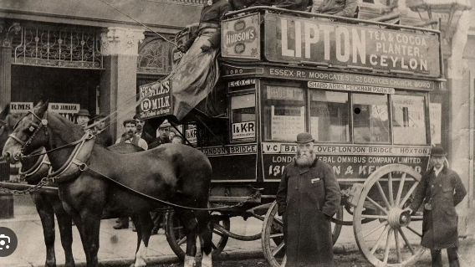
Spring

Travel & Transport – Now and Then
- Enquiry Question – How has transport changed over time?

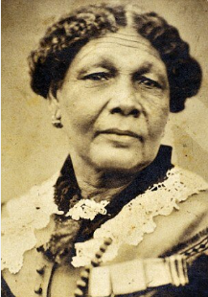
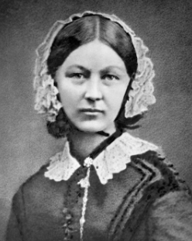

Summer

Nurturing Nurses - Mary Seacole & Florence Nightingale
- Enquiry Question – How have Florence Nightingale and Mary Seacole helped and influenced nursing and hospitals today?

Year 2 Journey
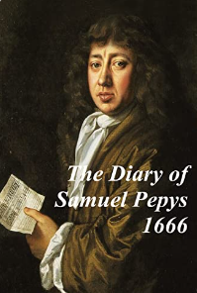
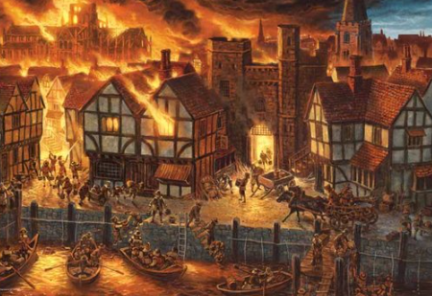

Autumn

The Great Fire of London
- Enquiry Question – Why did the Great Fire of London cause so much damage and what happened as a result?

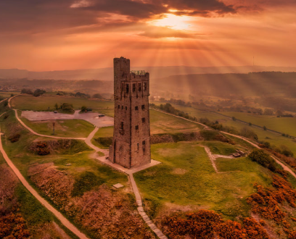
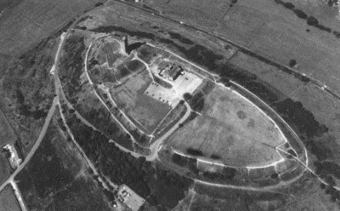
Spring

Castle Hill – Local History
- Enquiry Question – What is the history of Castle Hill?

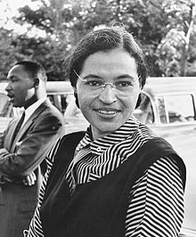
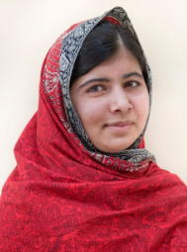
Summer

Fighting Injustice - Rosa Parks & Malala Yousafzai
- Enquiry Question – How have the courageous acts of Rosa Parks and Malala Yousafzai changed our world and inspired others?

Year 3 Journey

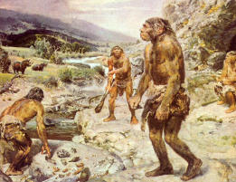
Autumn
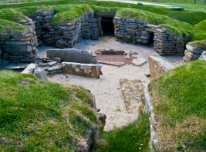
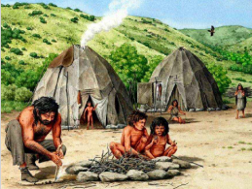
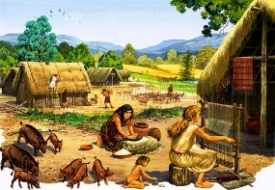

Pre-historic Britain – Stone Age
- Enquiry Question – How did pre-historic people live and how did their lives change and evolve over time?

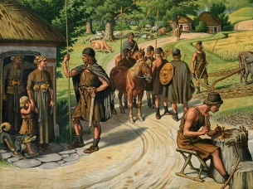
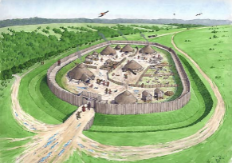
Spring

Pre-historic Britain – Bronze Age to Iron Age
- Enquiry Question – How did pre-historic people live and how did their lives change and evolve over time?

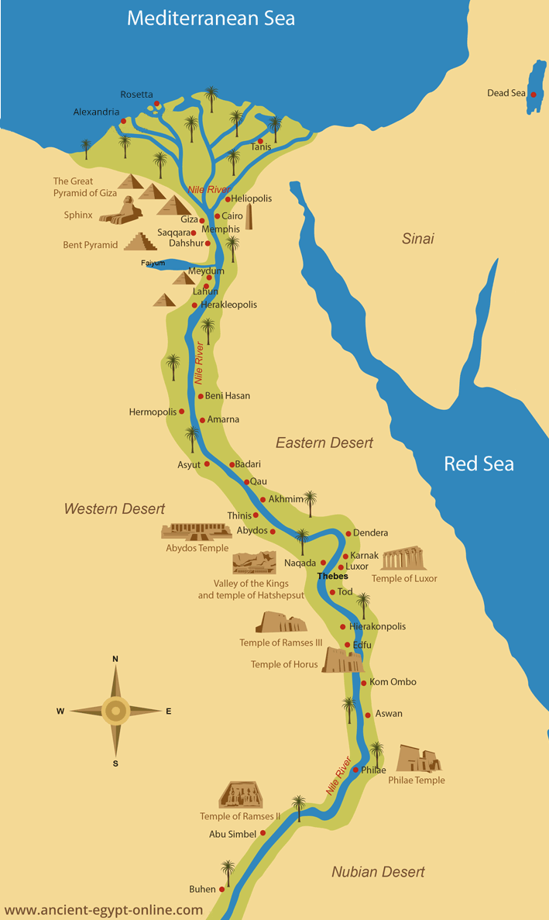

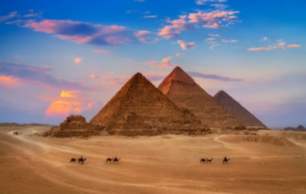
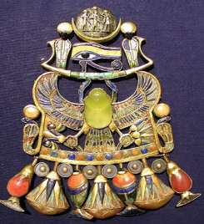
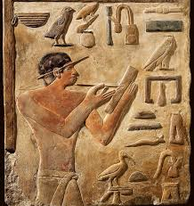
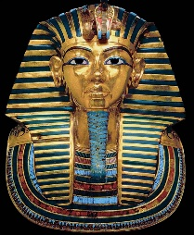

Ancient Egypt
- Enquiry Question – Why was the civilization of ancient Egypt so successful?

Year 4 Journey
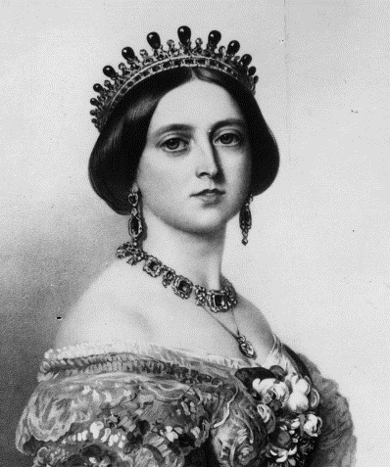
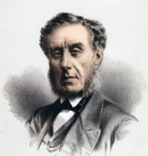
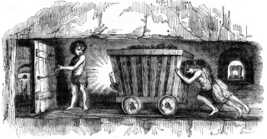
Autumn

Coal Mining – Local History
- Enquiry Question – What was it like to be a miner in Huddersfield in the 19th century?

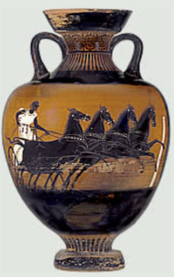
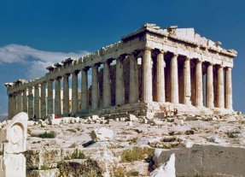

Spring
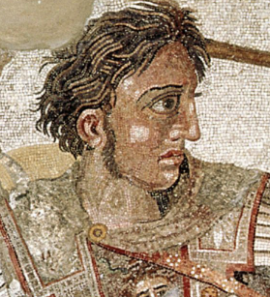
Ancient Greece
- Enquiry Question – Why is ancient Greece considered to be so influential to the modern world?

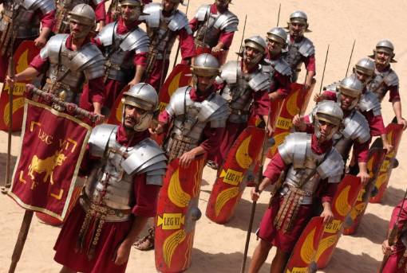
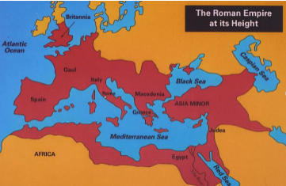
Summer

Roman Britain
- Enquiry Question – How did the Romans impact Britain?

Year 5 Journey
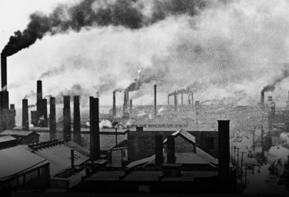

Autumn

Industrial Revolution
- Enquiry Question – How did Huddersfield and Britain change during the Industrial Revolution?

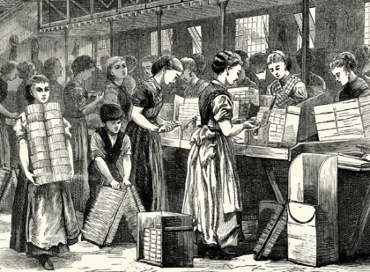
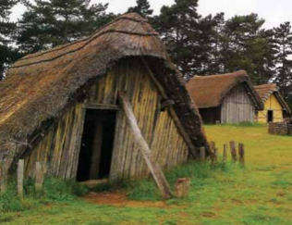
Spring

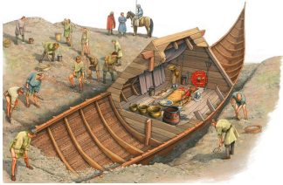
Anglo-Saxons
- Enquiry Question – Who were the Anglo-Saxons and how did they change Britain?

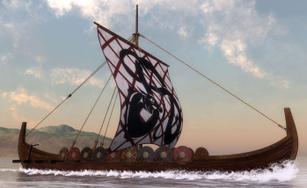
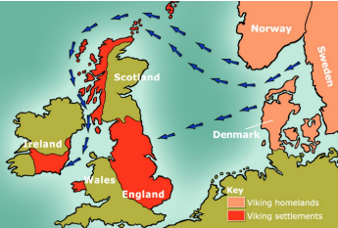
Summer

Vikings
- Enquiry Question – Who were the Vikings and what were the consequences of the Viking invasion in Britain?

Year 6 Journey
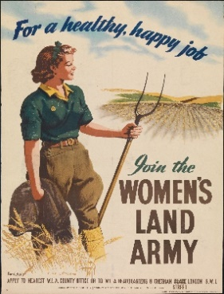
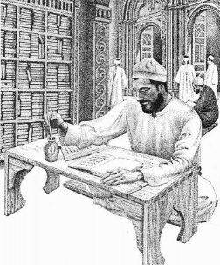
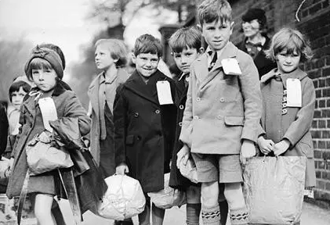
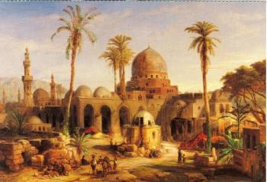
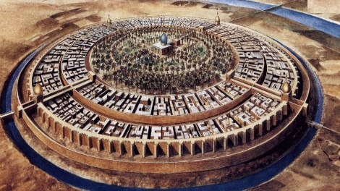
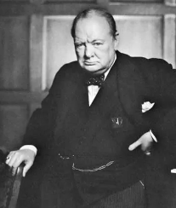
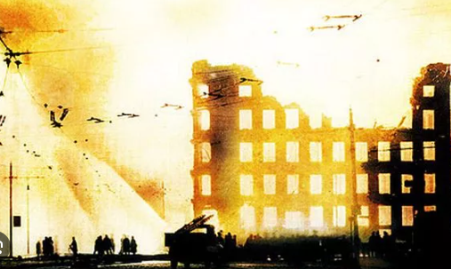
Islamic Civilisation
- Enquiry Question – What impact did early Islamic civilization have on the modern world?

World War II
- Enquiry Question – How were the lives of British citizens impacted during and after the Second World War?

Islamic Civilisation
- Enquiry Question – What impact did early Islamic civilization have on the modern world?

World War II
- Enquiry Question – How were the lives of British citizens impacted during and after the Second World War?

Spring & Summer
Autumn & Spring

